SET 4 – Product Inventory Management

1. Bar Chart – Quantity of Each Product
Aim:
To create a bar chart to visualize the quantity available for each product in the inventory.
Code:
product <- c("Product A", "Product B", "Product C", "Product D", "Product E")
quantity <- c(250, 175, 300, 200, 220)

barplot(quantity,
names.arg = product,
xlab = "Product",
ylab = "Quantity Available",
main = "Product Inventory")
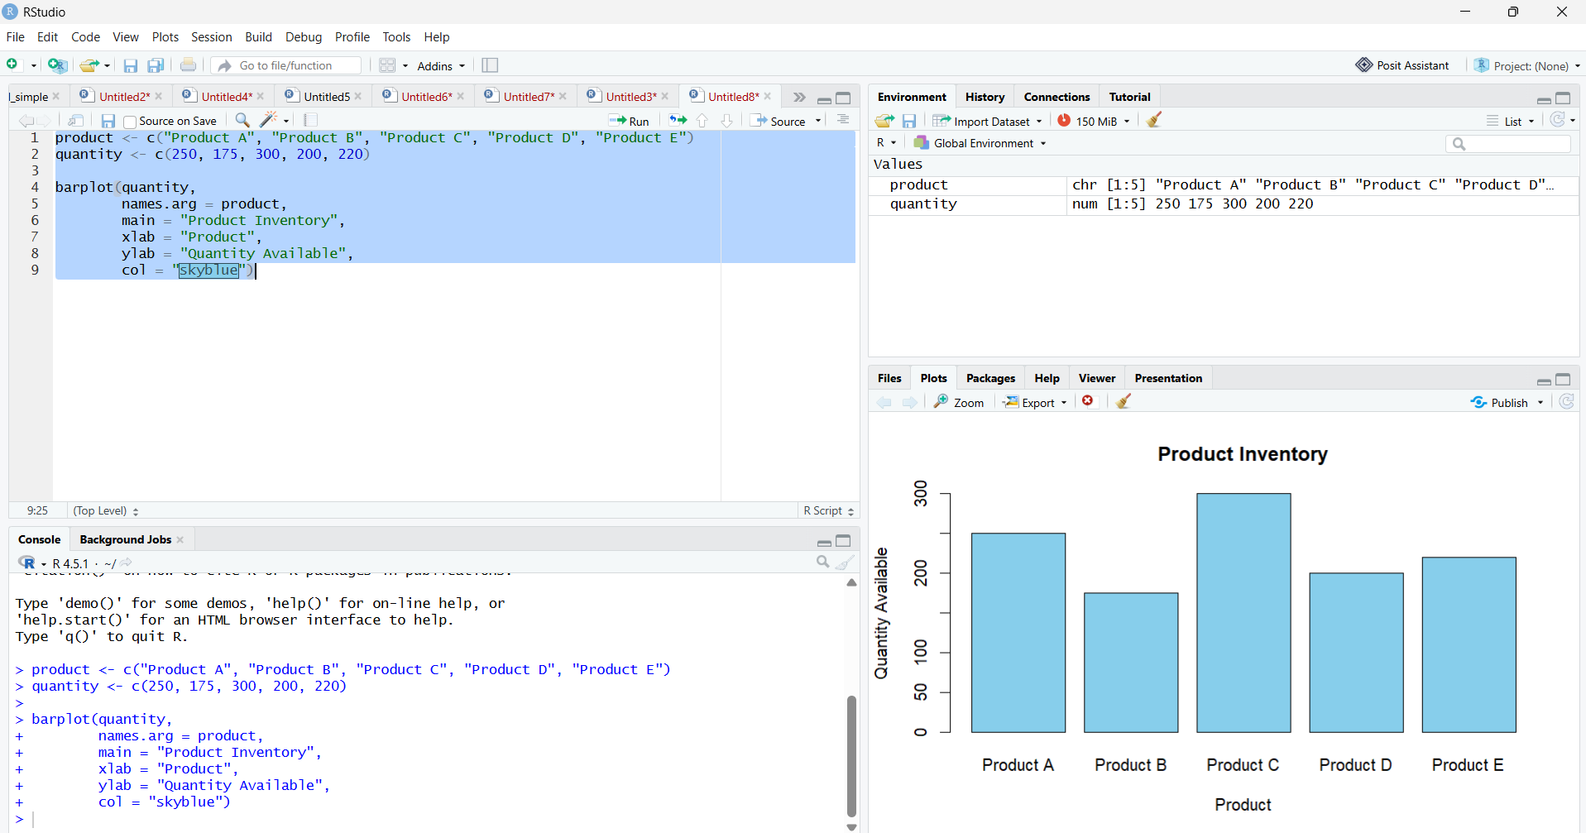

2. Stacked Bar Chart – Product Categories
Aim:
To create a stacked bar chart showing the quantity of products in different categories.
Code:
data <- matrix(c(100,150,100,
75,100,0,
150,150,0,
100,100,0,
120,100,0),
nrow = 5, byrow = TRUE)

colnames(data) <- c("Category 1", "Category 2", "Category 3")
rownames(data) <- c("Product A", "Product B", "Product C",
"Product D", "Product E")

barplot(t(data),
beside = FALSE,
legend.text = TRUE,
main = "Product Quantity by Category",
xlab = "Product",
ylab = "Quantity")

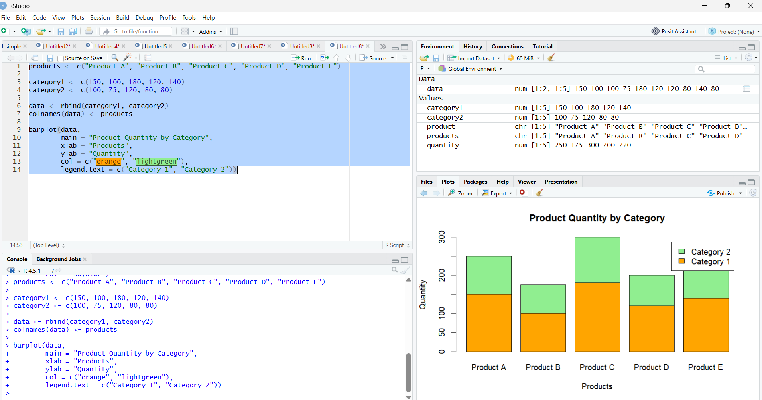

3. Scatter Plot – Price vs Quantity
Aim:
To create a scatter plot to study the relationship between product price and quantity available.
Code:
product <- c("A", "B", "C", "D", "E")
price <- c(100, 150, 80, 120, 90)
quantity <- c(250, 175, 300, 200, 220)

plot(price, quantity,
main = "Price vs Quantity Available",
xlab = "Product Price",
ylab = "Quantity Available",
pch = 19)

text(price, quantity, labels = product, pos = 3)
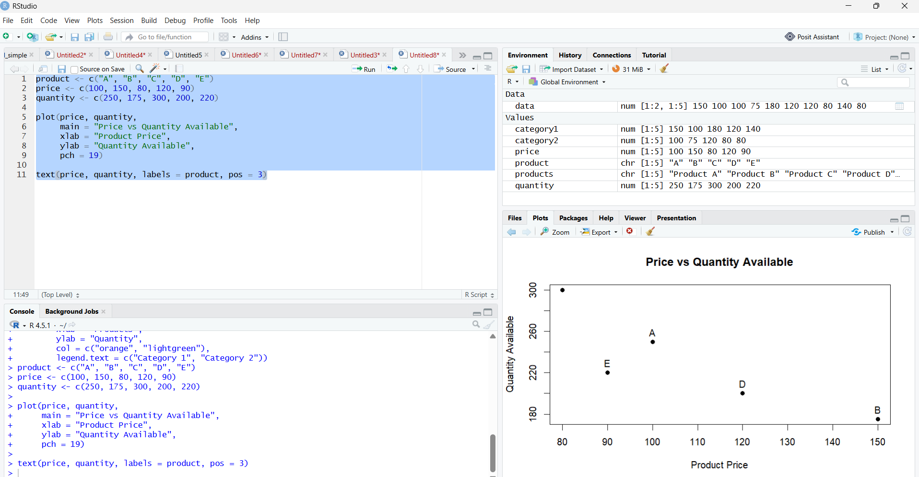

4. Develop a Tableau dashboard with the bar chart and stacked bar chart to allow users to interact
with the data.
Output:
